Cipher Challenge 5: The Pigpen Cipher

# Solve the message:

**Message:**

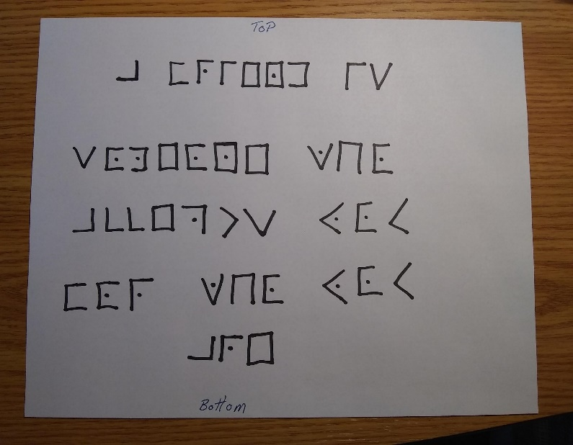

* What does the de-ciphered message say?

A Friend in Someone Who Accepts You for Who You Are.

# Explain the solution:

* What methods did you use to solve the cipher?

To solve the Pigpen cipher, one needs to first create a key to understand the symbols used in the grid. The key is typically a simple grid of the same shape and size as the cipher grid, with the letters of the alphabet written in their corresponding symbol in the grid.

* How long did it take to solve the cipher?

**About 3mins**

# Historical points or issues found:

What are some of the historical points or issues surrounding this cipher?

Historically, the Pigpen cipher has been used since the 18th century, and it was often used during the American Civil War and World War I. It was also used by notable figures such as Benjamin Franklin and Thomas Jefferson.

# Personal Reference List

(Did you record the reference in your personal reference list?)

"The Code Book" by Simon Singh

"Codes, Ciphers and Secret Writing" by Martin Gardner

"The Cryptoclub: Using Mathematics to Make and Break Secret Codes" by Janet Beissinger and Vera Pless